

Republic of the Philippines
Department of Education
National Capital Region
DIVISION OF QUEZON CITY SCHOOLS
Quezon City, Metro Manila

THIRD PERIODICAL TEST
MATHEMATICS IV
SY 2013 - 2014
NAME ______________________ Date ___________
Section _______________ Score___________

DIRECTIONS: Choose the correct answer. All answers must be simplified with the correct unit. If no base is given, use base 10. Calculator is NOT allowed.

- What is the quotient if x^{m} is divided by x^{n} ?
- x^{mn} B. x^{m + n} C. x^{m – n} D. x^{m/n}

- Which of the following has the least value ?
A. 3x⁰ B. 8^{-1/3} C. 1⁸ D. (1/25)^{-1/2}

- What is the exponential form of the logarithmic equation 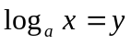?
- a = x^{y} C. y = a^{x}
- x = yª D. x = a^{y}
- Express 4⁻³ = 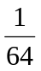 in logarithmic form.
A. 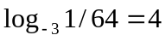 C. 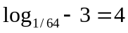
B. 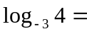 1/64 D. 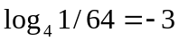
- If f(x) = 3^{5x}, what is the value of f () ?
- 4 B. 16 C. 9 D. 27

6. Imagine the graphs of y = 5^{x} and y = 5 ^{– x} . They are reflections of each other with respect to what
line? A. y = x C. y = 0
B. x = 0 D. y = − x

7. A culture of microorganisms doubles every hour. How many microorganisms will there be in the
culture after 4 hours if there were 250 of them at the beginning ?
A. 500 B. 2000 C. 1000 D. 4000

8. What is the x – intercept of any logarithmic function of the form y = log _{b} x, where b > 0, b 1 ?
A. – 1 B. 0 C. 1 D. 2

9. Which of the following is the inverse of the function 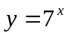?
A. 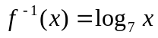 C. 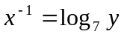
B. 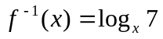 D. 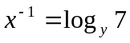
10. What is the range of any exponential function of the form y = b^{x}, where b > 0, b 1 ?
A. 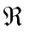 C. y 0
B. y 0 D. y > 0

11. Which one is the exponential form of the logarithmic notation log ₈ 64 = 2?
A. 64 = 8² C. 64² = 8
B. 2⁸ = 64 D. 8⁶⁴ = 2

12. What is the equation of a circle with radius of length one unit and with center at the origin ?
A. x = y² + 1 C. x² + y² = 1
B. x² - y² = 1 D. y = x² + 1

13. Which of the following is not an exponential change?
A. The process of cell duplication in which cell divides into two every hour.
B. The length of time a worker can finish a certain job.
C. A scanner is set to enlarge each dimension to 10% of its original size. The new copy will be
used as the original to make the next copy and so on.
D. A text message forwarded to two persons and each of them forwards the message to other two
and so on.
14. Which of the following does not define an exponential function?
A. f(x) = 2^{x} – 3 C. f(x) = - (5)^{x}
B. f(x) = 12 + 8x – x² D. f(x) = 3(7)^{x}

15. Find the inverse of f(x) = x + 1.
- f⁻¹(x) = x - 1 C. f⁻¹ (x) = - x -1
- f⁻¹(x) = - x + 1 D. f⁻¹(x) = 2x + 2

16. Given the exponential function y = 2^{x} + 10, what is its domain ?
A. B. x > 0 C. x 0 D. x 0

17. Which one has a graph same as that of y = 3^{x} but all points of which are moved 4 units above
the given graph ?
A. y = 3^{x} + 4 C. y = 3 ^{x + 4}
B. y = 3 ^{– x} + 4 D. y = 3 ^{– x + 4}

18. If the table represents y = Pb^{x} , what is P?
 |  | x | 1 | 2 | 3 | 4
 |  | y | 6 | 18 | 54 | 162

A. 3 B. 2 C. 6 D. 1

19. Which line is the asymptote of the function y = 5^{x} − 2 ?
A. y = 0 B. x = 0 C. x = −2 D. y = − 2

20. Which of the following equations serves as the mirror of any function and its inverse?
A . y = 0 B. y = 2x C. y = x D. y = ½ x

21. An angle in standard position has its initial side on the
A. positive x-axis C. positive y-axis
B. negative x-axis D. negative y-axis
22. How many degrees are there in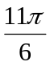 radians ?
A. 330 B. 540 C. 780 D. 660

23. What is the product of 2⁵ and 3² ?
A. 60 B. 128 C. 288 D. 300

24. Find the smallest positive coterminal angle of 155.
A. 145 B. 305 C. -205 D. 515

25. Convert 315 to radians.
A. 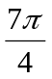 B. 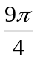 C. 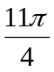 D.

26. What is the reference angle of 245 ?
A. 45 B. 65 C. 75 D. 85

27. Which of the following points lies on the unit circle?
A. (1/2, -½) C. (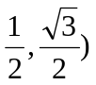
B. (-1/4,-3/4) D. (2/5,3/5)
28. A colony of bacteria doubles every 3 hours. At present there are 10,000 bacteria. How many
bacteria were there 6 hours ago?

A. 2,500 B. 5, 000 C. 20,000 D. 40,000

29. A unit circle is divided into 30 equal parts. What is the length of one of its equal parts?
A. 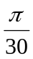 B. 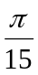 C. 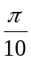 D. 

30. In which quadrant does 1230 lie ?
A. QI B. QII C. QIII D. QIV

31. Find x if x = log₁₀₀₀10⁶.
A. 3 B. 2 C. 10 D. 6

32. In the function f(x) = 735(1.09)^{x}, what is the rate of change?
A. 0.09% B. 9% C. 90% D. 0.9%

33. Manganese-52 has a half - life of 5 days. How much of the original amount will remain after 15 days?
- 1/2 B. ¼ C. 1/8 D. 1/16

34. Mrs. Brown invested Php 25,000.00 in a mutual fund for his children’s college education at 0.2%
compounded semi- annually. Which of the following gives the amount of his investment
after 10 years?
- y = 25,000(1.02)¹⁰ C. y = 25,000(1.001)²⁰
- y = 25,000(1.02)²⁰ D. y = 25,000(1.0001)²⁰

35. Find the value of x in log ₆ x = 3?
A. 18 B. 16 C. 36 D. 216

36. If log 2 = 0.3010 and log 3 = 0.4771, what is the value of log 24?
A. 0.013801 B. 0.13801 C. 1.3801 D. 13.801

37. Solve for x in log( x – 4 ) + log( x – 2 ) = log(2x – 7 ).
A. −5 and −3 C. 3
B. 3 and 5 D. 5

38. Given point P( x, y ) on the unit circle, what function does y stand for ?
A. sine B. cosine C. tangent D. cotangent

39. When written in single logarithmic form, which expression is equivalent to 4 log x + log y – 3log z?
A. log 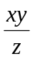 B. log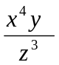 C. log 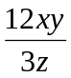 D. log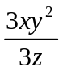

40. If a point P moves along the circumference of a unit circle in a counterclockwise direction and has
gone 2 complete rotations, how long is the distance traveled by P?
A. 4units B. 6units C. − 4units D. − 6units

41. How long is the hypotenuse of a right triangle if the lengths of the legs are 9 meters and 12
meters respectively ?
- 12 meters C. 14 meters
- 13 meters D. 15 meters
42. What is the value of f(x) if x = − 2, and f(x) = −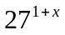?
A. 27 C. 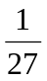
B. – 27 D. 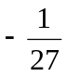
43. What is the range of the relation 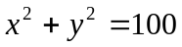?
A. 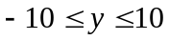 C.
B. 0 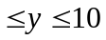 D. 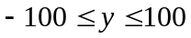

44. An angle of 60 in standard position has its terminal side in the fourth quadrant. Find the coordinates
of point P on the unit circle.
A. (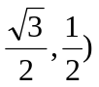 C. (
B. (- D. (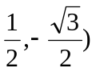
45. The point ( 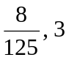 )belongs to 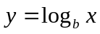. Find b.
A. B. 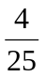 C. 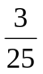 D.

46. Simplify : 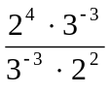
A. 2 B. 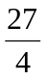 C.  D. 4

47. How much would Php15,000.00 amount to in 5 years at 4% compounded annually?
A. Php 17 500.00 C. Php 20 120.5
B. Php 18 249.79 D. Php 18 349.15

48. The diagonals of a rectangular lot intersects at an angle of 60 If the length of each diagonal is 30
meters, how long is the rectangular lot in meters?
A. 10 B. 15 C. 15  D. 10

49. Evaluate and simplify : 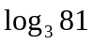 + 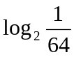 - 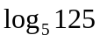.
A. -2 B. 8 C. 6 D. -8

50. If P is a point on the rotating ray with OP equal to 5 units, how long is the arc traced by P when the
ray has made 3 1/5 rotations counterclockwise from A(1,0)?

A. 75 units C. 100.5 units
B. 85.5 units D. 125.5 units

- e n d -

